Cell Theory

- All living things are made up of cells.
- Cells are the smallest working units of all living things.
- All cells come from preexisting cells through cell division.

Discovery of the cell timeline

Who | When | What
Hans and Zacharias Janssen Dutch lens grinders, | (1590),
Robert Hooke English Scientist | (1665),
Anton van Leeuwenhook Dutch Amateur Scientist,, | (1680),
Matthias Schleiden German Botanist | (1838),
Theodor Schwann German Zoologist | (1839),
Rudolph Virchow German Physician | (1855)
,

Cells Library Quest

Part I. Use the website http://www.cellsalive.com/cells/cell_model.htm
to answer the questions about animal and plant cells.

Click on “Animal Cell” underneath the diagram to view an animal cell.

- Click on “Nucleus.” What is found within the nucleus?

- Click on “Return to Cell Diagram.” Click on “Cytosol.” What is the cytosol mostly made up of?

- Click on “Return to Cell Diagram.” Click on “Golgi.” What is the Golgi apparatus important for?

- Click on “Return to Cell Diagram.” Click on “Lysosome.” What do lysosomes contain?

- Click on “Return to Cell Diagram.” Click on “Cell membrane.” What type of molecule makes up the double layer in the cell membrane?

- Click on “Return to Cell Diagram.” Click on “Mitochondrion.” Mitochondria produce ATP. What is ATP?

- Click on “Return to Cell Diagram.” Click on “Smooth Endoplasmic Reticulum.” What different functions does smooth ER play?

- Click on “Return to Cell Diagram.” Click on “Rough Endoplasmic Reticulum.” Why does the rough ER appear pebbled?

- Click on “Return to Cell Diagram.” Click on “Ribosomes.” Ribosomes are the site of what process?

Click on “Plant Cell” underneath the diagram to view a plant cell.

- Move your mouse over the plant cell to see the names of the organelles. Name five organelles found in a plant cell that were also studied in the animal cells questions above.

- What two organelles are found in the plant cell that you did not see in the animal cell?

- Click on “Cell Wall.” What molecule makes up cell walls?

- Click on “Return to Cell Diagram.” Click on “Chloroplast.” What substance inside the chloroplast makes it green?

Part II. Use the internet to help you label the following cells and find the function of the following organelles. Then, compare each organelle to an everyday object and explain why they are similar.
Animal Cell

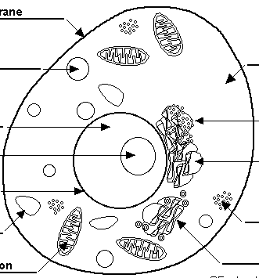

Plant Cell

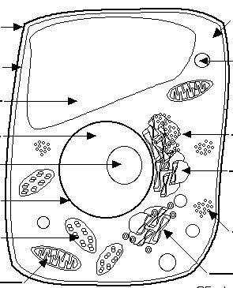

Organelle | Job | Compare to an everyday object  (Use a complete sentence. Follow the example.)
Nucleus |  | A nucleus is like a _____________ because
Cell Membrane

Endoplasmic Reticulum

Golgi Body

Ribosomes

Mitochondria

Lysosome

Cytoplasm

Vacuole

Chloroplast

Cell Wall

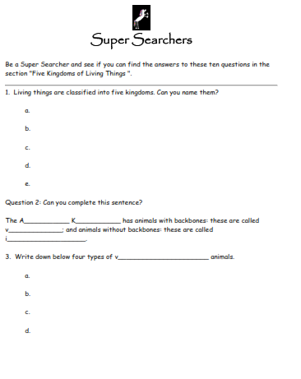
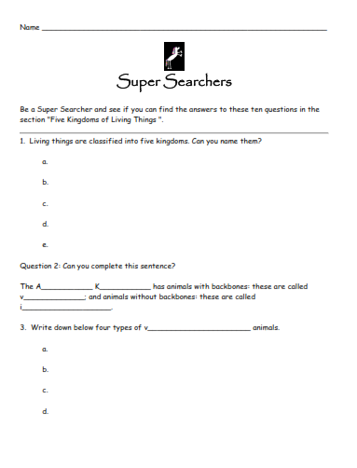

Human Tissues

As the cell multiplies it forms tissues. Tissues consist of lots of one type of cell. Organs in our body consist of two or more types of tissues.

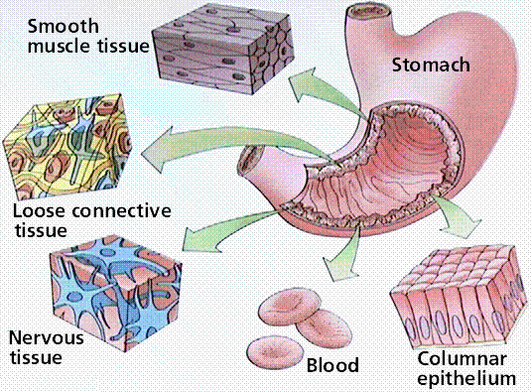

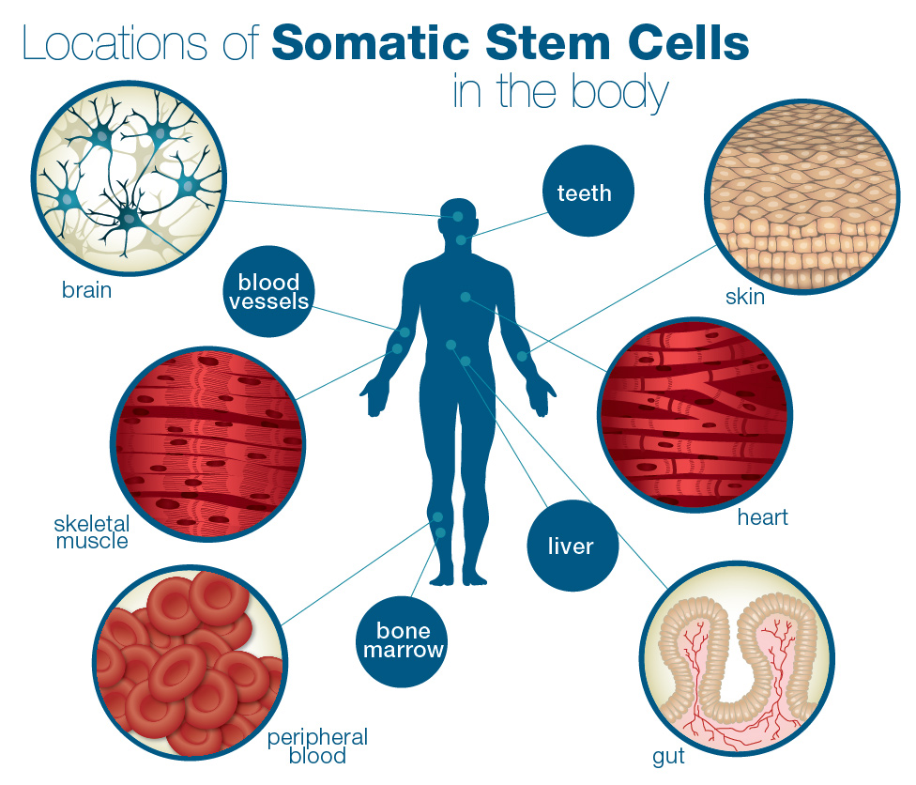
The Light Microscope

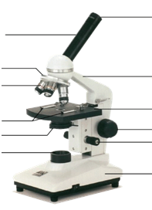

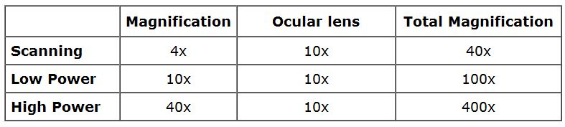

Guidelines for care

  - Always carry with 2 hands
  - Only use lens paper for cleaning
  - Do not force knobs
  - Always store covered

Using the Microscope

- When focusing a specimen, you should always start with the ___________ objective and then the _______ _________ __________ until clear.

- Once you've focused switch to_________. Use the _________ ___________ __________ to refocus. Then use the ________ _____________ __________ to make the image crystal clear. Again, if you haven't focused on this level, you will not be able to move to the next level.

- Now switch to ____________ (If you have a thick slide, or a slide without a cover, do NOT use the high power objective). At this point, ONLY use the Fine Adjustment Knob to focus specimens.

Recap
1. Scanning --> use _________ and ____ _____
2. Low power --> use _______ and _____ _____
3. High power --> use _________ only

Microscope Lab: The Letter “e”

Purpose:
Microscopes are only as accurate as their users. If you do not know how to use a microscope properly, you will have a difficult time finding specimens/cells in this unit. The letter “e” is something everyone should be familiar with (or at least I hope so). We all know that an “e” is round with a line connecting the upper half. Today, you will use that knowledge to determine how a microscope works.

You have two objectives to fulfill by the end of this lab:
- Properly use and focus a microscope from a low power to a high power objective lens.
- Determine what happens to the image of a specimen in the microscope.

Materials: Microscope
  - Slide
  - worksheet
  - Rule
Procedures:

Part A: Getting familiar with the microscope

Draw the letter E when viewed with the naked eye/

Magnification _____________

Specimen _______________

Now place the mounted letter ‘e’ under the microscope.

- Notice the eyepiece, what is the magnifying power of the eye piece? ____________

- Notice the low-power objective lens: It reads “4X lens.” It is used to view the whole slide. If total magnifying power of this lens is determined by multiplying the magnifying power of the eyepiece by the magnifying power of the objective, what is the total magnifying power of this objective? ______________

- Notice the high-power objective lens: It reads “Holds 40X lens.” Used to view object in even greater detail. What is the total magnifying power of this lens? _________________

Part B: Focusing the letter “e”

- Lower the stage using the coarse adjustment knob.

- Place the slide of the letter “e” on the stage and stabilize it with the stage clips. Center the “e” the best you can on the stage.

- Place the lowest (ie. 4X Objective Lens) into position.

- Looking into the eyepiece. SLOWLY use the coarse adjustment to raise the stage closer to the objective lens until the object (ie. “e”) comes into focus.

- Once the object is seen, it may be necessary to adjust the amount of light. To increase or decrease contrast, rotate the iris diaphragm slightly.

- Use the fine adjustment knob to sharpen focus if necessary.

- In the space provided, draw an outline of the letter “e” as it appears through the eyepiece.

Magnification: ______40X_______

Specimen: _________________

- Change Magnification. Place the 10X (medium power) objective lens into position. Follow procedures 6 – 8. Draw the outline of the letter “e” as it appears through the eyepiece.

Magnification: ______100X_______

Specimen: ____________________

- Lower the stage. Place the 40X objective lens into position. Follow procedures 6 – 8. Draw the letter “e” as it appears through the eyepiece.

Magnification: ______400X_______

Specimen: ____________________

Discussion Question: (full sentences)

1. Was the image of “e” “right side up” or “upside down”?

2. What happens to the microscope image when you move the microscope slide towards you?

3. What happens to the image when you move the microscope slide away from you?

4. How do you move your eyepiece image to the right?

Making slides of plant cells

- This activity involves making a wet mount slide of onion cells.

- The equipment that you will need for this activity are:
- A small piece of onion
- Slide
- Cover slip
- Microscope
- Iodine solution
- Tweezers
- A probe or toothpick

- To make your slide carry out the following procedure:
- Collect all your equipment.
- Make sure that your slide is clean.
- Using a pair of tweezers, carefully peel the layer of skin (epidermis) from your piece of onion.
- Place a small amount of the onion skin on to your slide.
- Place one drop of iodine solution onto the onion skin.
- Place the cover slip over the onion skin. Use the probe or toothpick as shown in the diagram.
- Use the microscope to look at the onion skin.

- To record your results, draw what you can see using the microscope.
Also write a description of what you have seen.

Bonus Lab: Determining the “Field of View”

Materials:
- Microscope
- Clear Plastic Ruler

Procedures:
- Using your Microscope procedure knowledge and a plastic clear ruler, determine how many millimeters are in the field of view under 40X, 100X, 400X.
- Draw each field of view and write the number of millimeters.

Magnification = 40X Magnification = 100X Magnification = 400X

# of mm =________ # of mm =____________ # of mm =____________

Animal Cells
Under the Microscope

- Work your way around the room and observe the various slides under the microscopes.
- Draw a diagram of what you observe.
- Write a brief description of what you observe.

Slide Type: __________________

Magnification: ________________

Description:
____________________________________________________________________________________________________________________________

Slide Type: __________________

Magnification: ________________

Description:
____________________________________________________________________________________________________________________________

Slide Type: __________________

Magnification: ________________

Description:
____________________________________________________________________________________________________________________________

Slide Type: __________________

Magnification: ________________

Description:
________________________________________________________

____________________________________________________________________________________

